Patron: Howden Ganley

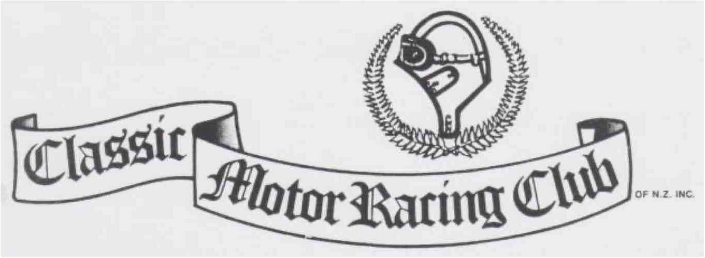

Club Secretary/Treasurer Paul Coghill 11C Coughtrey Street Saint Clair Dunedin 9012 Email: [info@classicmotorracinqclub.nz](mailto:info@classicmotorracinqclub.nz)

**PRESIDENT Vehicle Acceptance Committee.**

Nick Simpson [nicksimpson@xtra.co.nz](mailto:nicksimpson@xtra.co.nz) Wayne Murdoch Timaru 03 684 7872

Vice President

Wayne Perkins [wayneperkinss@gmail.com](mailto:wayneperkinss@gmail.com)

Past President Secretary/Treasurer

Barry Dorking. [Barryandclaredorking@gmail.com](mailto:Barryandclaredorking@gmail.com) Paul Coghill 0274 330 318

999999999999999999999999999999999999999999999999999999999999999999999999999999999999999999999999999999999999999999999999999999999999999999999999999999999999999999999999999999

Committee Members

**Newsletter Editor**

Brian Dixon Chch 033572134

Editorial contributions and advertising to:

Bruce Brown Timaru 03 688 6830

Trev Lister 50 Aylmer St,

Ross 7812

taandpa@xtra. co ,nz

Wayne Murdoch Timaru 03 684 7872

Dunedin [scottautosales@xtra.co.nz](mailto:scottautosales@xtra.co.nz)

Greg Scott

Website: www. classicmotorracingclub. co .nz

NEWSLETTER - April - June 2021.

The views expressed within this newsletter are not necessarily those of the Classic Motor Racing Club of NZ Inc or its elected representatives.

Please note: Verbal enquiries may be made to any committee member but all written communications including all acceptance information must be sent to the Secretary so that the relevant Committee Members may be sent a copy and be fully informed.

COMING EVENTS:

|  |  |  |
| --- | --- | --- |
| Date. | Event | Venue |
| 3 September 2021 | AGM | Benvenue Hotel |
| 4 September | Brooklands Challenge Meeting | Levels Raceway |
| 11, 12 and 13 Feb 2022 | SCH Southern Classic Meeting | Levels Raceway |

Your Editor could not make the Autumn Fling, but the snoop and the old timer have filled in superbly with reports and photos. Add in a wee extension of the past commentaries on 50’s racing and we are back in business. Happy reading.

The Old Timer’s Autumn Fling.

The Classic Motor Racing Club of New Zealand had their annual Autumn Fling on 8 May at Levels Motor Raceway. 51 entrants for five fields of cars. Muscle, Large Saloons, Formula Libra, small saloons, Vintage Car Club and Historic and Classic saloons Pre-1978. It was a mild morning, turning cooler after lunch with an easterly breeze.

The Muscle cars were dominated by Johnny Hepburn and his HQ Monaro with close racing by Rod Hayman’s Pontiac Firebird, Ryan Tinnelly’s Monaro, Mike Small and his Mustang and the always likeable Ray Hart in his Commodore.

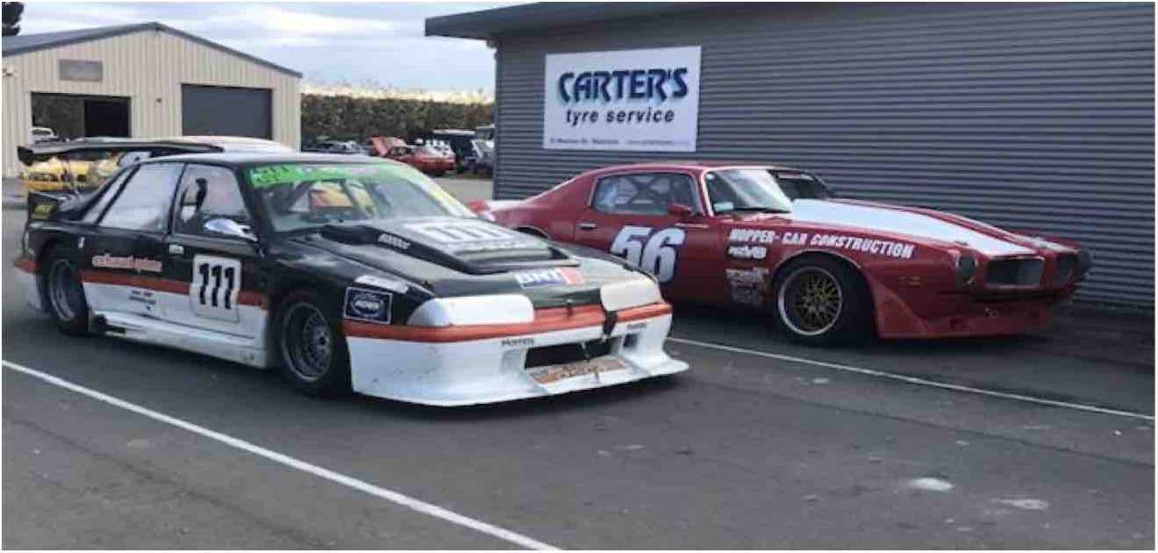

The small saloons had a good mixture of BMWs, Alan Farr in the Escort, Neil Green’s Prefect and son Jamie in the Datsun 1200, and Bob Denson’s Rutherford Anglia replica. The stand out performance of the day came from Brent Finlay and his Datsun 1200 Coupe. Brent has recently purchased this car off local legend Wayne Murdoch. Brent kept the BMWs honest at the front on his way to getting the old Shellsport Datsun into the 1 minute 10 second club.

The largest field was the recently formed class of Historic and Classic Saloons pre ‘78, with 21 starters. The Mustangs of Roy McDonald and Roger Cunningham dominated the field. There was close racing between Ewan McPherson in his Anglia GT, Steve Pauling’s Escort RS 2000, and Brownie’s 1200 SS Datsun. With Pauling coming out on top. This is an exciting class to race with. With Mini’s, the Triumph Vitesse of Paul Coghill, two Viva GTs, the Fiat Arbath Coupe of Blair Bishop, Tony Mann’s Alfa Romeo GTV and Craig Pidgeon’s Hillman Avenger.

Wayne Perkins is the contact for this racing class with the focus on non-contact racing for older cars.

Editors Apology to the Formula Libra Class.

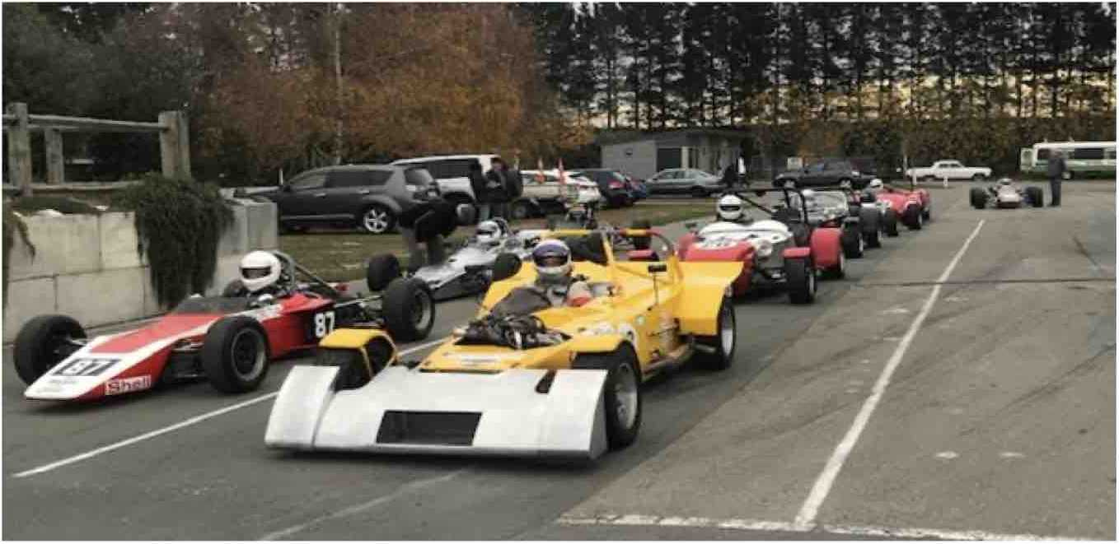

This grid was well supported on race day but missed out a race report. I trust that the photograph makes up in part for this omission. Feel free to grump to me at the next meeting. Thanks.

CMRC 2021 AUTUMN FLING AWARDS. MAY 8th LEVELS RACEWAY

RACE AWARDS

CLASSIC SALOONS GROUP ONE HISTORIC & CLASSIC SALOONS Pre78 FORMULA LIBRE CLASSIC LARGE SALOONS VINTAGE & HISTORIC

Brent Findlay Steve Pauling Ian Abbuthnott Raymond Hart Tracey Barrett

Datsun coupe Ford Escort 2000 Lola 342 FF Holden Commodore Lotus 23 R

CMRC CLUB AWARDS

Tony Johnston George Kear Steve Hand Greg Scott

LINDSAY NEILSON Best Performance.

PDL BEST NZ SPECIAL SCOTTS AUTO BEST PRESENTED ROSS CLIFFORD SPORTSMANSHIP driver

PETER GENDALL. Most Polished Performance.

Holden Commodore Kato Special Mini Cooper

Mentoring and coaching a new

Roy McDonald. Ford Mustang

VOLUNTEERS AWARD Roger Hill.

Roger assisted with documentation then proceeded to the tower and operated the computer for the starts and lights, a great help to all, thanks Roger

SPECIAL AWARD. Mark Mclaughlan, Ford Mistral.

This was Marks first time drive at a race meeting and he acquitted himself very well. Mark has purchased Greg Scott’s immaculate Ford Mistral which is a very quick car, well done Mark.

Well done to all of our competitors and congratulations to our race day award recipients.

Happy winter maintenance, and hope to see you all at our season start, the AGM sept 3rd and our Brooklands Challenge, September 4th 2021

Well Raced and the presentation of cars is just great. Cheers, Brian.

Observations From the Snoop:

Hello from the Snoop. My report for the March Newsletter was absent due to either being a tad slack or just recovering from the SCH Southern Classic. But I have been beaten into submission to get this out for the coming Newsletter. I trust that those who have had a busy racing season are now warming the garage to commence the end of season maintenance on your poor old race car as the new season will be upon us before we know it.

My racing season was shortened severely by the 13-car incident at the Scope meeting, and repairs are slowly coming together. The rear suspension rebuild is now complete and back in place. The front suspension and wheels are back together along with the nose box and wings ready for the painter. The main part of the body is back and will also go to the painter this week, with hopefully the rest of the body not to far away. Thanks to information from fellow racer Ewart Anderson of Wellington I was able to contact 42 Degree Wheels in Taupo, the only company in New Zealand that can spin the new inner rims (mine are three piece) that I need. I should have these back shortly. My thanks to John and Graeme who have helped machine, weld and make parts for me which I could not source anywhere. It is amazing the help available at times like this and I am sure that many of you have experienced this at times of need to get your cars back on the track.

Our Autumn Fling was another successful meeting if the comments are anything to go by. Entries were good and we introduced timing for the first time at a club day event. This came about when we were promised a grid of twenty Formula Fords that would be attending the FF 50th Anniversary Festival held at Ruapuna the week before our meeting. However only two or three bothered to turn up. However, the timing was appreciated and we will implement it for the Brooklands Challenge in September.

We had good numbers for the Classic and Historic pre ‘78 class and the Classic Group 1 Saloons. Racing was great in both these classes. I was up on the Tower watching for possible award winners when I saw a little Datsun make a hell of a start and attempt to slip through an even smaller gap to separate a couple of Mustangs at the first comer. That tightened a few backsides in the tower, I can tell you. A bit ambitious but thankfully little damage.

Thanks to the lads that brought out the large saloons and produced some very impressive racing. The class was small but the racing was close and exact. The Sports/GTs and the Libre class were combined due to numbers and also produced some good racing. The VCC were impressive as well.

At the driver’s briefing safety and driver behaviour were emphasised due to the damage at the last three meetings at other tracks. Everyone was invited to take a large chocolate fish, courtesy of the organiser, as the farms are all taken.

Class and Club Awards are listed elsewhere.

Planning for the 2022 SCH Southern Classic is underway and invitations to various classes have been sent out. Mobil 1 Muscle Cars and the Classic and Historic pre ‘78 classes have committed again and we hope that the Historic Sports Sedans from the north will accept as well. The historic Formula Fords have expressed an interest to attend as part of a three-race series, and the regular support classes will be there.

See you there. Cheers. The Snoop.

The Snoops Autumn Fling Photo Montage:

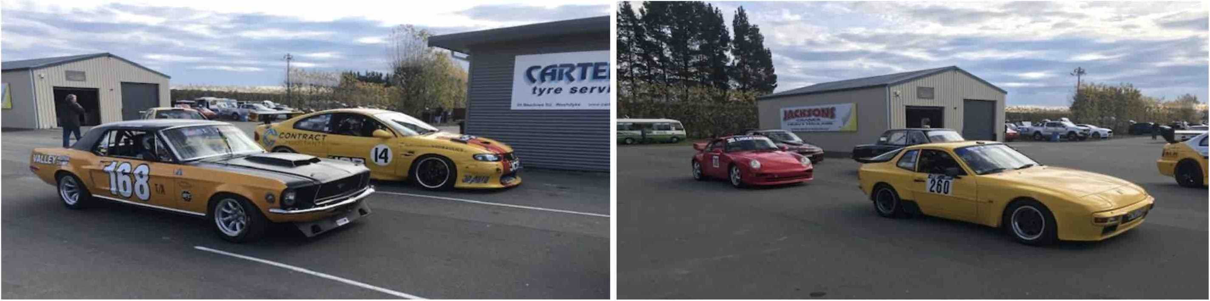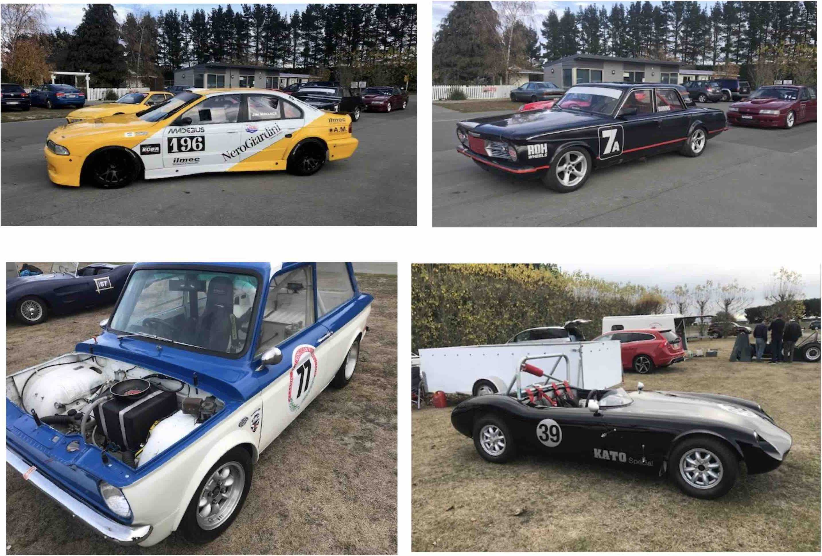

Rules? What Rules? The Reims 12 Hour Sports Car Race 1953.

Editors Note: This circuit had seen a 12-hour race before, but long before - in 1926. The ‘53 race was an add on to the Formula 2 French Grand Prix, held before the Grand Prix, not after it. The intent was to create a 2-day carnival of motor sport, to rival the Le Mans Race.

In view of the dramas in both races the crowd would have got their money’s worth. The 12 Hour sports car event started at midnight and ran until noon the following day, with the Grand Prix occupying the afternoon. This timing made it difficult for a driver to do both races. It could be done, but on a time limit for GP drivers to do their sports car stint and then rest up for the GP. The GP was to run for at least 3 hours so not many attempted both events. A good thing as it turned out as the sports car race degenerated into a farce. The race report below is from the Motor Sport Magazine, with editorial comments if required.

As midnight approached on Saturday the whole of the pit-area was superbly floodlit, bands played, fireworks were let off, cabaret turns were performed on open-air stages and the restaurants and stands were full to overflowing. Starting a race in the dark was indeed a novelty to the public but the drivers of the faster cars were not looking forward to it. A Le Mans start at 4 o’clock in the afternoon is hair-raising enough and the added handicap of plunging out of a pit-area like daylight into the pitch black of midnight was not a comforting thought.

Officially there was no general classification in this race, though naturally everyone was interested in the team that was going to go the farthest distance in the 12 hours. There were three categories, the first being up to 750cc, the second 750-2,OOOcc and the third over 2,000cc, so that there were to be three races and three winners.

That was officially, but generally speaking the Le Mans atmosphere had so invaded Reims that a general classification was expected. As at Le Mans the cars lined up in order of engine size with the drivers on the opposite side of the road and a quick glance down the line showed two Cunninghams, both open models, the new one driven by Fitch-Walters and the old one by Cunningham-Johnson, three Talbots as at Le Mans driven by Rosier-Cabantous, Levegh-Meyrat and Mairesse-Grignard, the 4.5-litre Ferrari of Maglioli-Carini, a 4.1 open Ferrari of Hill-Chinetti, the Moss-Whitehead works Jaguar, the Ecurie Ecosse, Jaguar driven by Scott-Douglas and Sanderson, a French 120C of Roboly-Simone, the Abecassis-Frere HWM with transverse-leaf ifs, and torsion bar de Dion rear, two Gordinis, the 3-litre of Behra-Lucas and a 2.5-litre of Trintignant-Schell.

(Editor’s Note: The Motorsport narrative has the Ferrari Berlinetta with a 4.5 litre engine for this race but other sources say it kept its earlier 4.1 litre engine, with the 4.5 being fitted later).

On account of a supercharger Constantin’s Peugeot 203 was also in this group, which comprised category three. In the middle class were the two Le Mans Bristols, bravely having another go, driven by Macklin-Whitehead and Fairman-Wilson, three assorted Gordinis, Mieres-Guelfi aud Layer-Rinin with two open versions of the 2-litre and Bourelly-Creapin with a 1.4-litre coupe.

Clarke and Scott-Russell were driving Gerard’s Le Mans Fraser-Nash, the owner running in the Grand Prix. Salvadori and Crook had the works Fraser-Nash coupe. There were two 2-litre Ferraris, a coupe driven by Picard-Pozzi and an open one by Legenier-Rubirosa, while Said’s blue and white l,350cc Osca made up the class. Naturally the 750cc class was especially for French care and had most of the Le Mans competitors running, with D.B., Panhard, Monopide, Renault, and V.P.- Renault, making a total of fifteen in this class.

It is doubtful whether more than two drivers saw the flag fall, but they all got away with the Ferrari coupe soon going into the lead, followed by Behra (Gordini), Walters (Cunningham), Trintignant (Gordini), Moss (Jaguar), and Abecassis (HWM). Mieres led the 2-litre class, ahead of the other works Gordini and the Fraser-Nash coupe went out with clutch trouble. The drivers soon got used to the darkness and the Ferrari drew away from the rest of the field, while Behra came in with a flat rear tyre. It was found that the new car was too low for the jack, when the tyre was flat, and the whole staff tried lifting, but to no avail; eventually another jack was produced and the wheel changed, the car now being way back among the 2-litre class by the time it restarted.

By 1 am things had settled down, the Ferrari being still farther ahead, followed by Trintignant, Walters, Moss, Abecassis, and Rosier with the first of the Talbots. The leading 2-litre Gordini had broken its accelerator pedal, letting the Loyer-Rinin car take its place, while Plantivaux and Bruwaere were leading the babies with one of the super-streamlined Panhards. Graham Whitehead retired one of the Bristols with a broken clutch before Macklin had a chance to drive, and Roboly’s nice new Jaguar ran a big-end.

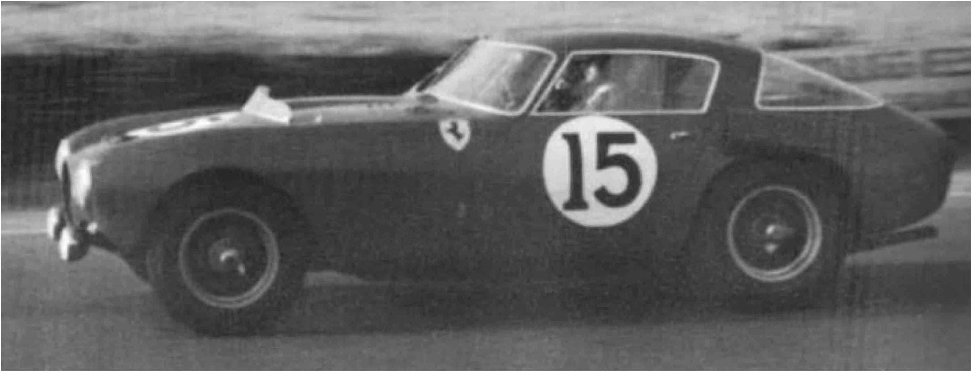

(Editor’s Note: Your editor is yet to find a photograph of the lead Ferrari at this race. The photograph above shows it at the prior Le Mans event. It carried race number 18 at Reims).

Just before the 2.30am pit-stops for fuel and new drivers began. At at one end of the pits the marshals allowed only two mechanics to work on the cars, while at the other end marshals were allowing three. Officially the rules said that one mechanic could refuel and while he was doing that two others, or one and the driver, could work on the car, but no one was too sure and it was soon clear that few of the marshals had had practice at supervising long-distance race pit-stops. However, nobody bothered too much and everyone refuelled and changed drivers, fuel was spilt everywhere, no one caught fire, by a miracle, and the numbers around the cars depended on the nationality of the pit crew.

The Ferrari continued to retain its lead, except during the pit-stop reshuffling. Carini took some time to get into the stride of Maglioli but by 3am he achieved it near enough. Before handing over Maglioli had made fastest lap in 2 min 42.8 sec, a speed of 184.5 kph, which would have put him in the second row of the Grand Prix line-up. The Ferrari now seemed quite uncatchable and sounded perfectly healthy and the order in Class 1 was the Ferrari, followed some way back by the new Cunningham. Trintignant was still driving the 2.5-litre Cordial with Whitehead having taken over from Moss on the Jaguar, Frere driving the HWM, and Rosier driving the leading Talbot single- handed. Loyer and Rinin were still leading the 2-litres and the Chancel brothers had now taken the lead in Class 3 with the second streamlined Panhard.

According to the regulations lights had to be kept on until 5 am irrespective of weather conditions and when the Ferrari went past at 4.30 am with no lights it was quite obvious that it was asking to be disqualified. A visit to the Ferrari pit to hear what the organisers had to say was imperative and as Charles Faroux, the Race Director, approached he had “disqualification” written all over his a face. But before he reached the pit Comet’s Panhard coupe went by without any lights, as did several DBs, the French-owned 2-litre Ferrari, one of the Gordinis and many others on sidelights only. The “disqualification” changed to a warning and the pit waved frantically to Carini to put the lights on again, as did all the other offenders, while Faroux gesticulated to those on sidelights, and nobody really knew whether the regulations meant sidelights or headlights.

Returning towards his office Faroux met Divo, the Assistant Race Director, and at that point the Ferrari came in for a pit stop. It was refuelled and Maglioli got in, and then fuel gushed out of the filler onto the ground. Many hands pushed the car clear of the spilt fuel, the engine burst into life and Maglioli was back in the race. This was 4.40 am and as he left there were no rear lights showing, while to those behind the car, including the Race Director, the car appeared to have been push-started.

Without more ado a meeting of the marshals was called and five minutes later the loudspeaker announced that “no more lap times would be taken for Ferrari No. 18 as it had infringed numerous regulations.” No mention was made that it had been disqualified, merely that no more times would be taken. It was now nearly three laps in front of the second car and going at the same furious pace.

Ugolini, the pit manager, was soon at the Director’s office to find out what rules had been infringed and a furious argument started, which went on for over 1 hours. From this point the race turned into a farce as partiality had been shown over the interpreting of rules and, much more serious, the organisers flagrantly ignored one of the most important rules of the International Sporting Code. As Faroux stated to Ugolini, a decision had been made; why or how or whether it was justified was another matter which could be discussed, but the actual decision to stop taking times for the leading Ferrari could not be altered.

When a car is disqualified, for whatever reason, it must be stopped by the Race Director with a black flag and the number of the car concerned. This was not done and the Ferrari continued unchecked, while the loudspeakers, at 4.50 am announced that it had completed 100 laps of the circuit.

The rights or wrongs of the disqualification depended entirely on the statements of the marshals concerned and when questioned more closely by Ugolini these statements began to vary. For example, those behind the car said it left without any lights, those in front said the headlights were on; those behind said the car was push-started, those beside the car said Maglioli pressed the starter, though no one was sure whether the car was still rolling or stationary at the precise moment. The question of the number allowed to work on the car arose again and it was clear that opinions or interpretations of the rules varied, but still the Ferrari was allowed to circulate; nothing was said about putting all the lights out before 5 am!

After a while “Lofty” England appeared on behalf of the Jaguar that was now officially leading, to suggest that the Ferrari be stopped if it was out of the race, as Moss was needlessly racing with it, thinking that it was still leading. Roche produced a black flag which he gave to Divo, who in turn produced a number 18 which be gave to Faroux. Meanwhile the public were screaming abuse and calling for the reasons for the uproar. Faroux with the number and Divo with the flag waited for the Ferrari to appear and first of all showed them to a red Panhard coupe and then to the 2-litre Ferrari coupe.

When Maglioli finally appeared, there was a distinctly unassured air about the Race Director, and as the car passed, he held up the number and pointed to the car while Divo kept the flag by his side. Naturally Maglioli did not stop and a lap or two later Divo went down to the beginning of the pit area and waved the black flag, but with no number, so again Maglioli did not stop. By now the whole affair had got completely out of hand and the officials were all for sitting down and forgetting the whole incident, but Ugolini would not have it and continued to keep the pot boiling.

No more official attempts were made to stop the Ferrari and just before 5.30 am, amidst an uproar from the public, the Ferrari pit signalled Maglioli to come in, which he did immediately, accompanied by a continuous chant of sympathy from the crowd, some of whom proceeded to pluck the decorative flowers from the grandstands and throw them on the car as it stopped. Maglioli justified his action of not stopping before by simply quoting the International Sporting Code, pointing out that a number on its own meant nothing, neither did a black flag.

This utter farce and mismanagement on the part of the officials caused much of the interest of the race to die away, the crowd began to disappear and go to sleep, and the remaining hours dragged heavily. While all this had been going on Fitch had crashed the new Cunningham while in the lead,writing it off completely, Schell had pushed the leading Gordini in with its starter motor permanently locked to the flywheel, the H.W.M. had broken its rear suspension and pit stops continued, with fuel splashing about everywhere, cars being pushed about, and more than three people working on cars, depending on which end of the pits they were at. What had been a first- class race had turned into a shambles.

As those people who had been to bed began to filter back to the course after breakfast it was seen that Moss-Whitehead were lending with the Jaguar, followed by Rosier- Cabantous in the Talbot and Cunningham-Johnson in the Cunningham. Loyer-Rinin were still leading in Class 2 from Fairman- Wilson in the Bristol and Picard- Pozzi in the Ferrari coupe, while many of the little cars were still going round, the Chancel brothers in the lead.

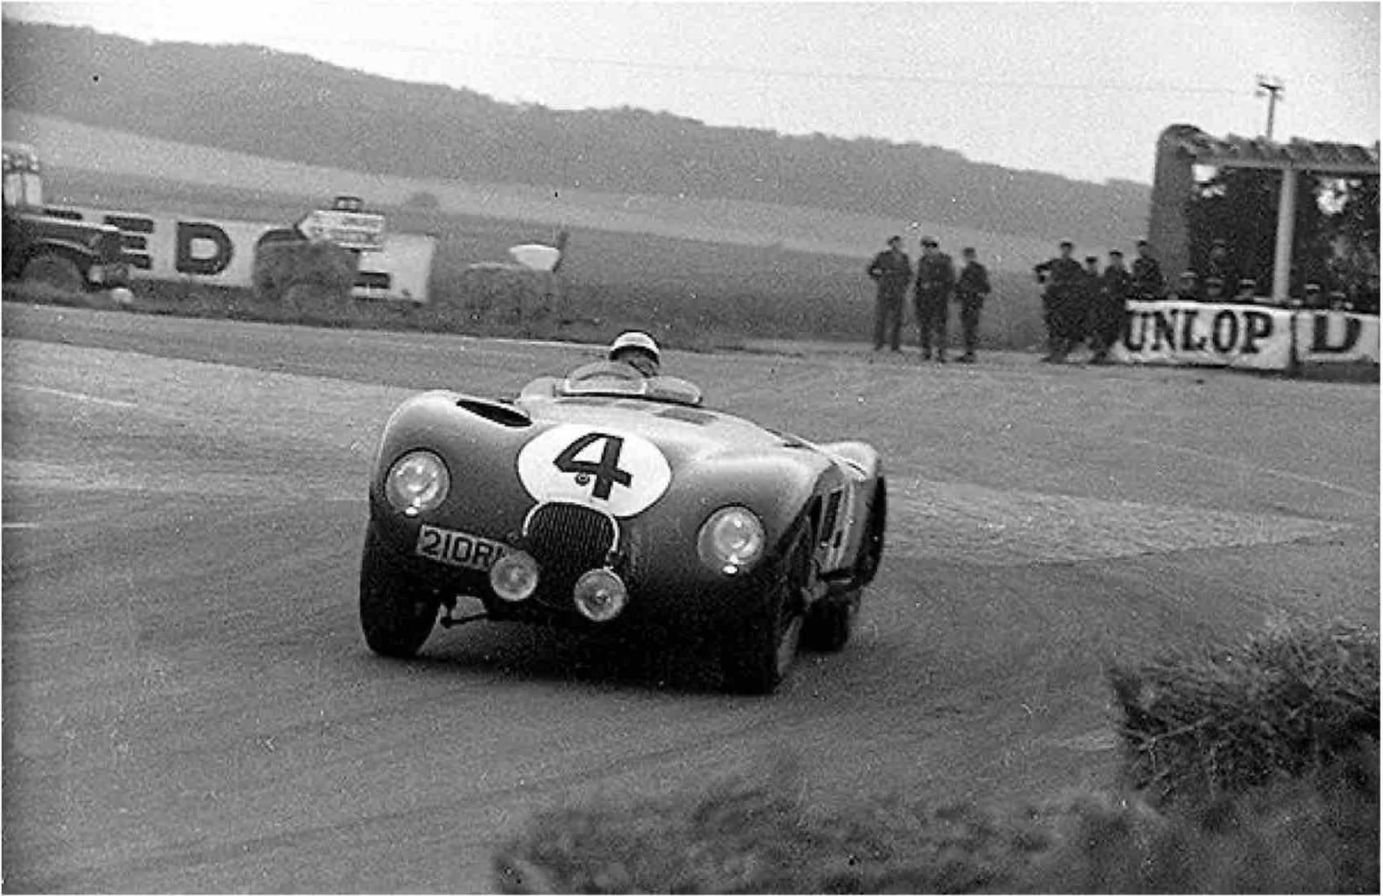

Little of the daybreak excitement was known to them and no official announcements were made, so that opinions could only be gathered from hearsay, and various improvements were made to the actual happenings by the sleepers. Ferraris finally packed up and went home to bed threatening to return to Modena and not run in the Grand Prix, while Carini started the coupe on the starter and drove it round the back of the pits, unintentionally disproving any stories about the car being unable to be started other than by pushing.

As the heat of the day approached and the hours to midday ticked slowly away it was becoming rather obvious that the experiment of starting a race at midnight was not a good one, from the point of view of those keen ones who stayed up time whole time. Also, the much advertised music and dancing that was supposed to go on all night had fizzled out before the race even started.

As Moss brought the dark green Jaguar in to the finish he was loudly acclaimed by the crowd that was beginning to assemble again for lunch. Cabantous finished second in the works Talbot, followed by Johnson in last year’s Cunningham, which he had shared with the owner. That, officially, was Class 3, though to the crowd it was the race itself.

FACEBOOK PAGE:

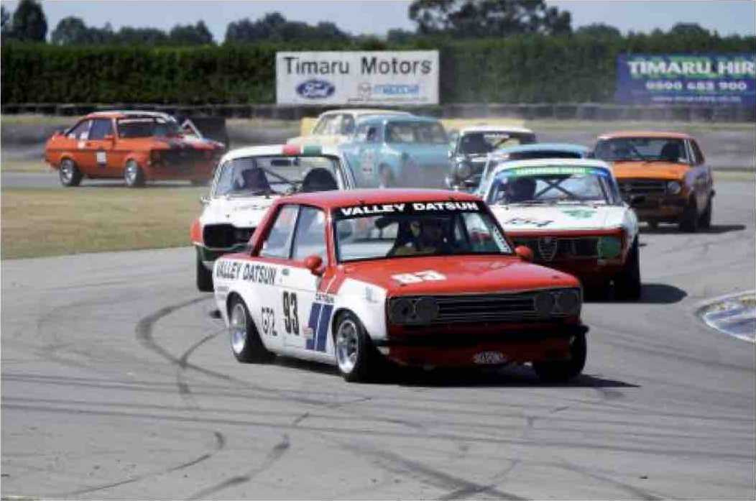

Our club Facebook address is

[www.facebook.com/cmrcnz?fref=ts](http://www.facebook.com/cmrcnz?fref=ts) The normal posting rules apply. The post will be promoted as long as it is positive and about club type stuff. Don't forget to “like” the page and ask your friends to like it as well.

WEBSITE [www.classicmotorracingclub.co.nz](http://www.classicmotorracingclub.co.nz)

Remember this is your website and you can add photos to it to make it more interesting.

The latest entry form is always on the Website as is the membership form.